Enterprise Ephemeral
Test Platform
Architecture & Design Document

Version: 1.0 — POC Edition
Scope: Short-lived ephemeral environments — AWS, GCP, On-prem Kubernetes
Sample application: Spring Boot + PostgreSQL on AWS
Classification: Internal — Platform Engineering

Document purpose
This document describes the functional architecture of the ephemeral test platform, includes all architecture diagrams, and provides a complete worked example using a Spring Boot application on AWS. It covers the full lifecycle from PR trigger through infrastructure teardown.

1. Overview
The ephemeral test platform creates a complete, isolated infrastructure stack when a pull request is opened, runs the application's integration test suite against real cloud services, and tears everything down when the PR closes or a TTL expires.

Three core principles drive the design:
- Any team, any stack — a single env.yaml file is the only contract teams need to write.
- Any cloud — the same ProviderAdapter interface works on AWS, GCP, and on-prem Kubernetes.
- Zero residual cost — destroy always runs, even when tests fail.

POC scope
This document covers the core ephemeral lifecycle only. Governance features such as the policy engine, self-service portal, and chargeback dashboards are out of scope for the POC but are designed to plug into the same architecture without changes to the core.

1.1 Key design decisions
Component | Responsibility
ProviderAdapter SPI | Platform core has zero cloud SDK imports. All cloud operations go through one Java interface with four methods: provision, seedData, runTests, destroy.
env.yaml contract | Teams write one file. The platform reads it, validates it, and handles everything else. No Terraform knowledge required.
Workspace isolation | Every PR gets its own Terraform workspace (pr-{number}). All resource names carry the workspace prefix — no collisions between concurrent PRs.
Destroy guarantee | CI uses if: always() on the destroy step. A TTL watchdog also destroys stale stacks independently, catching environments the CI job left behind.
Idempotent seed | Test data is loaded with INSERT ... ON CONFLICT DO NOTHING. The seed script is safe to re-run on a retried job.

2. Ephemeral lifecycle
The platform executes a four-stage linear lifecycle for every PR. The stages run in strict sequence. If any stage fails, the destroy stage still runs unconditionally.

Stage | Name | What happens
1 | Trigger | PR opened or updated. GitHub Actions fires. CI reads env.yaml, runs mvn package, builds a Docker image, and pushes it to the container registry tagged pr-{number}.
2 | Provision | Terraform creates an isolated VPC and provisions the application container, database, and object storage — all named with the pr-{number} prefix. Terraform outputs (endpoints, secret ARNs) are captured for the test stage.
3 | Test execution | Flyway migrations run first to create the schema. The data loader pulls CSV files from object storage and bulk-inserts them. The test runner executes the integration suite with live endpoints injected as environment variables. Results post to the PR as a GitHub check.
4 | Destroy | terraform destroy removes every resource created in stage 2. The Secrets Manager secret uses recovery_window_in_days = 0 for instant deletion. The TTL watchdog fires after the configured timeout as an independent safety net.

2.1 Architecture diagram — ephemeral lifecycle
The diagram below shows the complete lifecycle from PR trigger through provisioning, test execution, and teardown. All AWS resources are created inside an isolated VPC per PR and removed on destroy.

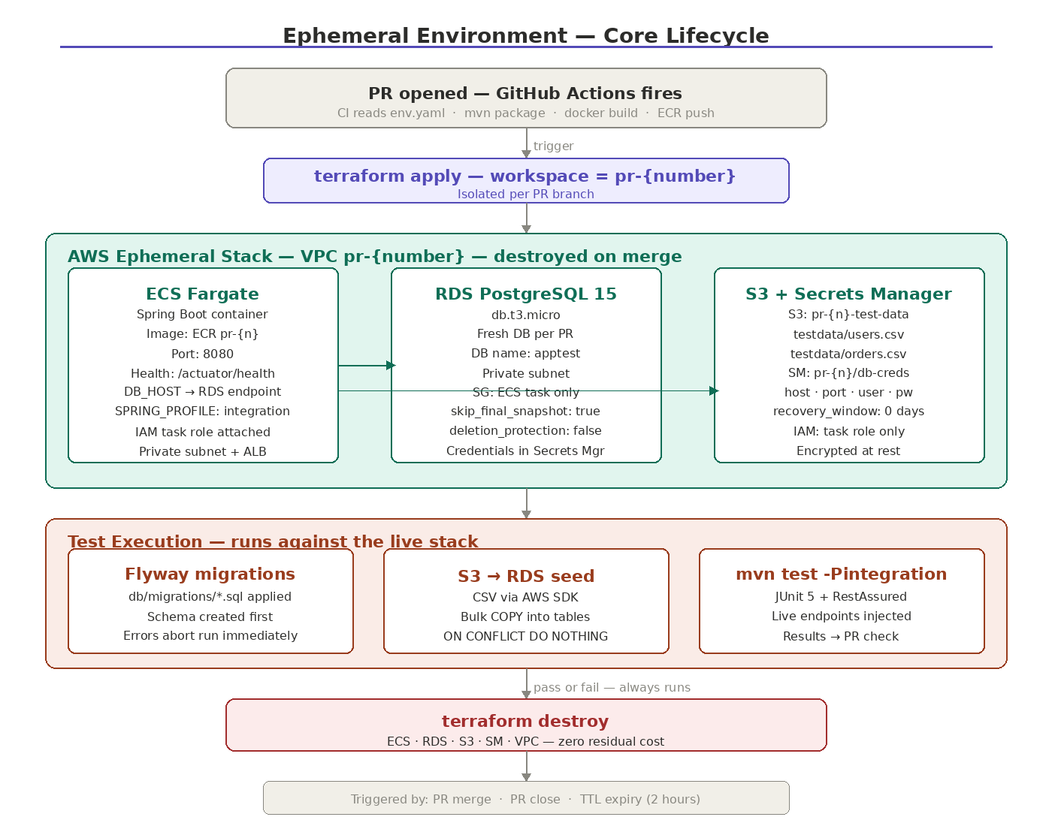
Figure 1 — Ephemeral lifecycle: trigger → provision → test execution → destroy

3. Functional architecture
The platform is structured in five layers. Each layer has a single responsibility and communicates downward only. The diagram below shows all five layers and their internal components.

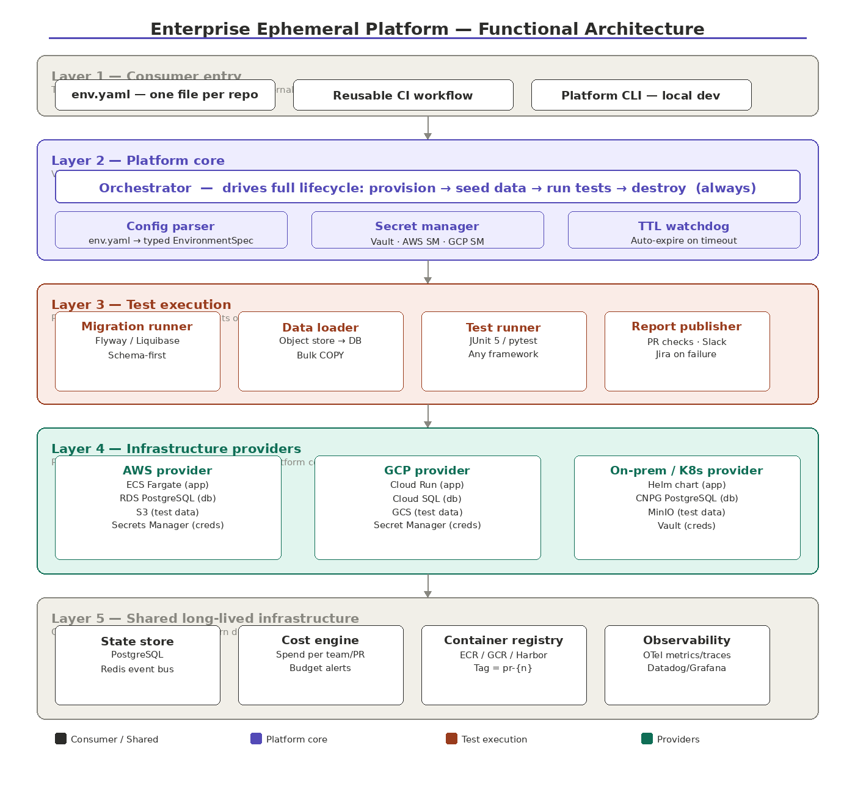
Figure 2 — Functional architecture: five-layer platform structure

3.1 Layer 1 — Consumer entry
The only surface application teams interact with. Three entry points are supported:
- env.yaml — one file per repository. Declares the application stack, database, test data source, notifications, and TTL.
- Reusable CI workflow — a GitHub Actions workflow_call that wraps the platform Docker image. Teams call it with two lines.
- Platform CLI — a command-line tool for triggering ephemeral environments from a developer laptop.

3.2 Layer 2 — Platform core
The shared library, versioned and distributed as a Docker image. Contains the Orchestrator, Config parser, Secret manager, and TTL watchdog. Has zero cloud SDK imports — only calls ProviderAdapter.

Component | Responsibility
Orchestrator | Drives the full lifecycle. Calls provision(), seedData(), runTests(), destroy() in sequence. Wraps destroy() in a finally block so it cannot be skipped.
Config parser | Parses and validates env.yaml into a typed EnvironmentSpec. Validates schema version, TTL limits, and required fields before any cloud resource is touched.
Secret manager | Abstraction over Vault, AWS Secrets Manager, and GCP Secret Manager. Returns a DbCredentials object — orchestrator never handles raw passwords.
TTL watchdog | Scheduled job running every 5 minutes. Destroys any environment whose startedAt + ttl is in the past. Handles CI runner failures and manual cancellations.

3.3 Layer 3 — Test execution
Four focused components that run in sequence after provisioning. All are provider-agnostic — they work identically on AWS, GCP, and on-prem.

Component | Responsibility
Migration runner | Applies Flyway or Liquibase migrations from the path declared in env.yaml. Schema is always created before data is loaded.
Data loader | Downloads CSV files from object storage (S3, GCS, or MinIO) and bulk-loads them using PostgreSQL COPY. Uses ON CONFLICT DO NOTHING for idempotency.
Test runner | Shells out to mvn test -Pintegration (or any declared command). Injects APP_ENDPOINT, DB_HOST, DB_SECRET_REF as environment variables. Captures exit code and test report XML.
Report publisher | Reads test report XML and posts results to the GitHub PR check, Slack channel, and optionally creates a Jira ticket on failure. Runs even when tests exit non-zero.

3.4 Layer 4 — Infrastructure providers
Pluggable implementations of ProviderAdapter. All three expose the same four methods. Adding a new provider requires only implementing the interface and writing the corresponding Terraform or Helm configuration.
- AWS provider — ECS Fargate (app), RDS PostgreSQL (db), S3 (test data), Secrets Manager (credentials).
- GCP provider — Cloud Run (app), Cloud SQL (db), GCS (test data), Secret Manager (credentials).
- On-prem / Kubernetes provider — Helm chart (app), CloudNativePG operator (db), MinIO (test data), Vault (credentials), one Kubernetes namespace per PR.

3.5 Layer 5 — Shared long-lived infrastructure
Owned by the platform team and never torn down. Provides the backbone all providers depend on.
- State store — PostgreSQL tracking every environment lifecycle event, plus Redis pub/sub event bus.
- Cost engine — per-team, per-PR spend tracking with monthly budget caps and chargeback CSV export.
- Container registry — ECR, GCR, or Harbor. All providers pull images tagged pr-{number}.
- Observability — OpenTelemetry metrics, traces, and logs forwarded to Datadog or Grafana.

4. Sample application: Spring Boot + PostgreSQL on AWS
This section documents the end-to-end ephemeral environment for a Spring Boot REST application backed by PostgreSQL running on AWS. It is the reference implementation for teams onboarding to the platform.

4.1 Architecture diagram — Spring Boot on AWS
The diagram below shows every AWS resource provisioned per PR, how they connect, and the complete test execution and teardown sequence.

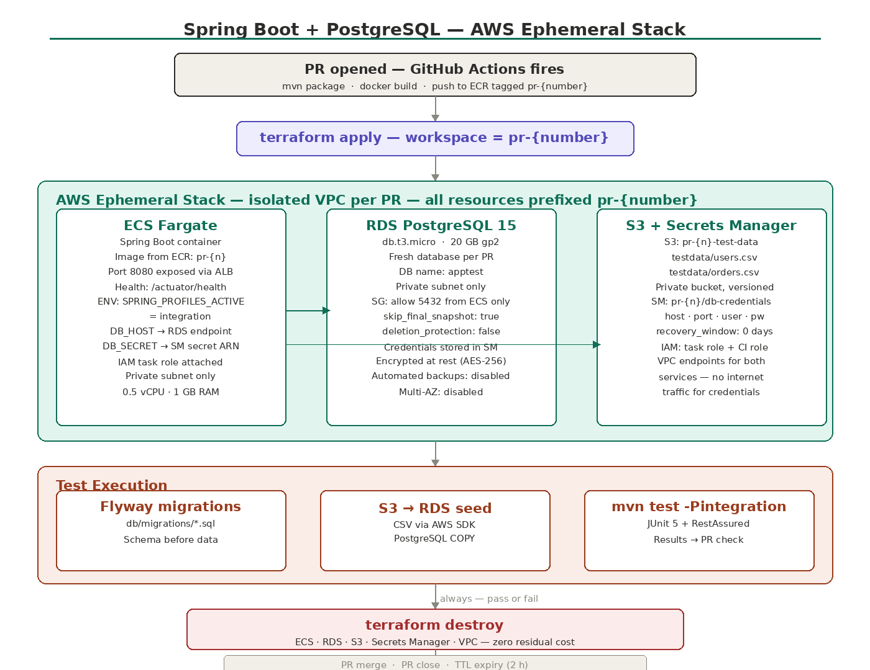
Figure 3 — Spring Boot + PostgreSQL on AWS: complete ephemeral stack

4.2 env.yaml for Spring Boot
The following env.yaml is placed in the root of the application repository. It is the only file the team writes:

apiVersion: ephemeral-platform/v1
metadata:
team: payments-squad
app: payment-service

environment:
ttl: 2h
provider: aws

database:
engine: postgres
version: "15"
size: small # db.t3.micro
migrations: db/migrations/

testData:
source: object-storage
path: testdata/ # testdata/users.csv, testdata/orders.csv

app:
image: auto # built from this repo's Dockerfile
port: 8080
healthCheck: /actuator/health
env:
SPRING_PROFILES_ACTIVE: integration

notifications:
onFailure: slack:#payments-alerts

4.3 AWS resources provisioned per PR
Terraform creates the following resources inside a workspace named pr-{number}. All resources are removed when the PR closes:

AWS resource | Configuration | Purpose
ECS Fargate task | pr-{n}, 0.5 vCPU, 1 GB | Runs the Spring Boot container. Health check at /actuator/health. IAM task role grants S3 and Secrets Manager access. Private subnet only, traffic via ALB.
Application Load Balancer | Internal, private subnet | Routes HTTP traffic to ECS on port 8080. ALB DNS name becomes APP_ENDPOINT injected into the test runner.
RDS PostgreSQL 15 | db.t3.micro, 20 GB gp2 | Fresh database per PR. Security group allows inbound 5432 from the ECS task only. skip_final_snapshot = true, deletion_protection = false for fast teardown.
S3 bucket | pr-{n}-test-data, private | Holds CSV test data files. Bucket is emptied then deleted during destroy. VPC endpoint avoids public internet traffic.
Secrets Manager secret | pr-{n}/db-creds, 0d window | Stores host, port, username, password as JSON. Instantly deleted on destroy. Task role and CI runner role have GetSecretValue permission.
VPC + private subnets | Private subnets, no public IP | Isolated network per PR. VPC endpoints for S3 and Secrets Manager. ECS and RDS in separate private subnets.

4.4 Test execution sequence
Stage | Name | What happens
1 | Flyway migrations | Reads db/migrations/*.sql and applies them to the fresh RDS instance. Schema is created before any data is loaded. Migration failures abort the run immediately.
2 | S3 → RDS data load | Downloads testdata/users.csv and testdata/orders.csv from S3 using the AWS SDK. Bulk-loads both files using PostgreSQL COPY. ON CONFLICT DO NOTHING for safe retries.
3 | mvn test -Pintegration | Runs the JUnit 5 suite with APP_ENDPOINT, DB_HOST, and DB_SECRET_REF injected as env vars. Tests use RestAssured against the live application. Surefire XML captured as CI artifact.
4 | Report publish | Posts pass/fail counts and duration to the GitHub PR check. On failure, posts a summary to the configured Slack channel.
5 | terraform destroy | Runs unconditionally (if: always()). Empties S3, removes ECS, deletes RDS, removes Secrets Manager secret, destroys VPC. Typical duration 4–6 minutes.

4.5 JUnit 5 test pattern
Tests read all endpoints from environment variables, making them identical whether running locally against Testcontainers or against the live AWS stack:

@SpringBootTest(webEnvironment = RANDOM_PORT)
class PaymentIntegrationTest {

// Injected by platform — same var name locally and in CI
static final String APP = System.getenv("APP_ENDPOINT");

@Test
void createPayment_returnsCreated() {
given()
.body(new PaymentRequest("usr-001", 49.99))
.post(APP + "/payments")
.then()
.statusCode(201)
.body("status", equalTo("PENDING"));
}

@Test
void getPayments_returnsSeedData() {
get(APP + "/payments?userId=usr-001")
.then()
.statusCode(200)
.body("total", greaterThanOrEqualTo(2)); // seed loaded 2+ orders
}
}

4.6 Destroy triggers
Three independent mechanisms guarantee the stack is always removed:
Component | Responsibility
PR merge | CI destroy job has needs: test and if: always(). Runs immediately after the test job regardless of pass or fail.
PR close | A separate workflow listens on pull_request: types: [closed] and runs terraform destroy with the PR workspace name.
TTL watchdog | Platform scheduled job runs every 5 minutes. Any environment whose startedAt + ttl is past triggers a destroy call, catching stacks orphaned by runner timeouts or OOM kills.

5. Repository structure
The platform is a multi-module Maven project. Application teams only interact with env.yaml and the reusable CI workflow:

ephemeral-platform/ # platform team owns this
platform-core/ # ProviderAdapter SPI, Orchestrator
aws-provider/ # AWS implementation
gcp-provider/ # GCP implementation
k8s-provider/ # On-prem / Kubernetes implementation
infra/
aws/ # Terraform HCL for AWS
gcp/ # Terraform HCL for GCP
k8s/ # Helm charts for on-prem
platform-cli/ # CLI wrapper for local dev
.github/workflows/
ephemeral-platform.yml # reusable workflow teams call

application-repo/ # application team owns this
env.yaml # ONLY file the team writes
.github/workflows/
ci.yml # calls ephemeral-platform.yml@v1
src/
db/migrations/ # Flyway SQL migrations
testdata/ # CSV seed files

6. Future extensions (post-POC)
The following capabilities are designed to plug into the existing architecture without changes to platform core. The data models and interfaces are already in place in the POC.

Component | Responsibility
Policy engine | Routes teams to the right provider using YAML rules — data residency, team tags, cost schedules. Plugs in between env.yaml parsing and orchestrator invocation.
Self-service portal | Web UI for team registration, live environment status, audit logs, and cost reports. Reads from the state store. No changes to the lifecycle engine.
Cost & governance | Per-team, per-PR spend tracking with monthly budget caps. The cost engine subscribes to the Redis lifecycle event bus and can be enabled independently.
Multi-database support | Add MySQL or MSSQL by implementing a new migration runner variant. The ProviderAdapter interface is unchanged.
Azure provider | Implement ProviderAdapter with ACI, Azure Database for PostgreSQL, and Blob Storage. No changes to platform core.

Upgrade path
Because the POC and full enterprise platform share the same ProviderAdapter interface, state store schema, and env.yaml contract, there is no migration required when activating extensions. Teams onboarded during the POC continue working without changes to their repositories.

7. Glossary

Term | Definition
Ephemeral environment | A complete infrastructure stack — app, database, object storage — created on demand for a single PR and destroyed when the PR closes.
ProviderAdapter | The Java interface every cloud provider must implement. Defines four methods: provision, seedData, runTests, destroy.
EnvironmentSpec | The typed Java object produced by parsing env.yaml. Contains all resolved endpoints and secret references after provisioning.
TF workspace | A Terraform workspace named pr-{number}. All resource names carry the workspace prefix to prevent collisions between concurrent PRs.
TTL watchdog | Scheduled platform job that destroys any environment whose configured time-to-live has elapsed, regardless of CI status.
env.yaml | The single file application teams write. Declares the app stack, database, test data source, TTL, and notification channels.
Seed data | Test data loaded into the database before the test suite runs. Stored as CSV files in object storage, loaded via PostgreSQL COPY.
Platform core | Shared library containing Orchestrator, Config parser, Secret manager, and TTL watchdog. Has zero cloud SDK imports.
CNPG | CloudNativePG — Kubernetes operator managing PostgreSQL clusters as first-class Kubernetes resources. Used by the on-prem provider.
COPY (PostgreSQL) | PostgreSQL command for bulk-loading data directly into a table. Significantly faster than individual INSERT statements for large seed datasets.

End of document — Enterprise Ephemeral Test Platform v1.0 | Includes 3 architecture diagrams

